Why Generation Study Abroad

U.S. graduates need to be prepared to work and live in this fast-paced interconnected world.

IIE created Generation Study Abroad® in 2014 to double and diversify the number of
U.S. college students studying abroad by the end of decade. IIE is proud of its long-standing commitment to education abroad since we helped create the first junior study abroad program in the 1920s.
Through education abroad, students can gain important global competencies such as language, cross-cultural communications, empathy, adaptability, and problem solving skills. Strong evidence indicates that students who study abroad have better grades, experience less attrition and graduate from college at higher rates than students who do not study abroad, and have a competitive edge on the job market.
Yet the number of U.S. students studying abroad is far too low. Fewer than 10% of U.S. undergraduates study abroad during their degree program and only one quarter of those are from underrepresented groups. Our aim is to encourage meaningful, innovative action to drive up the number of U.S. student who have the opportunity to gain international experience through academic study abroad programs, internships, service learning, and non-credit educational experiences.

Doubling Study Abroad
2.6 Million students earn an undergraduate degree each year
2.6 Million
600K

300K

Only 300,000 of these have studied abroad before graduating

Our Goal: 600,000
students studying abroad annually by the end of the decade

740+ Worldwide Partners
The five different types of commitment partners reflect the diversity of the Generation Study Abroad network:

408 U.S. Universities & Colleges
189 International Partners
110 Organizations
23 Education Associations
19 Country Partners

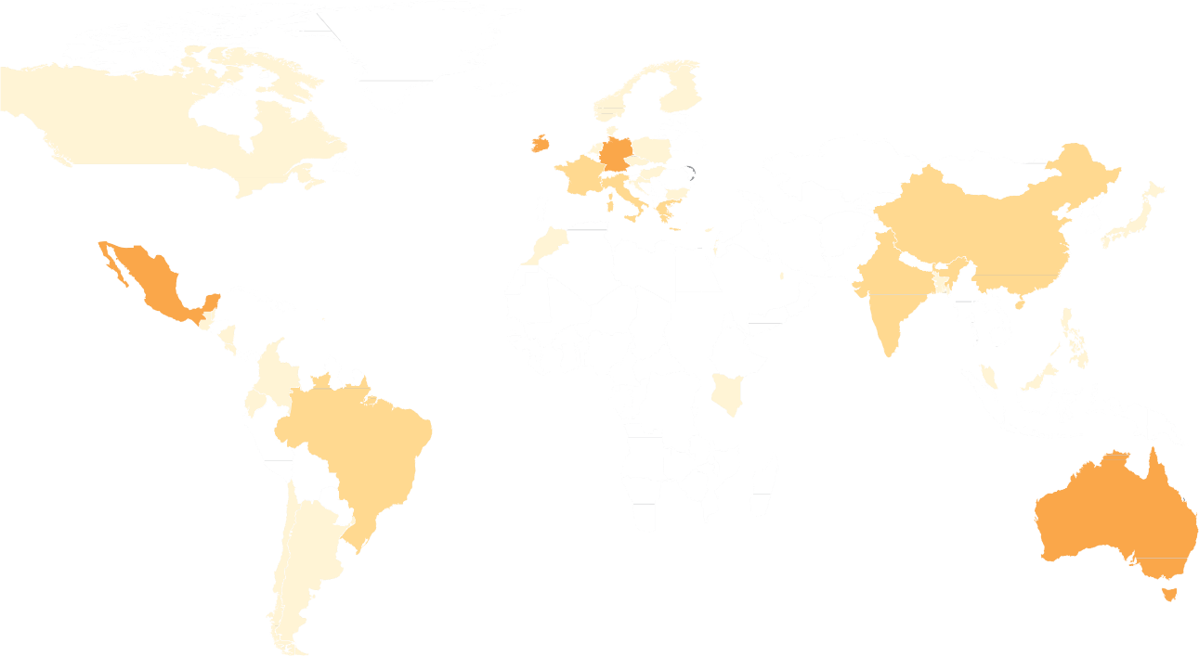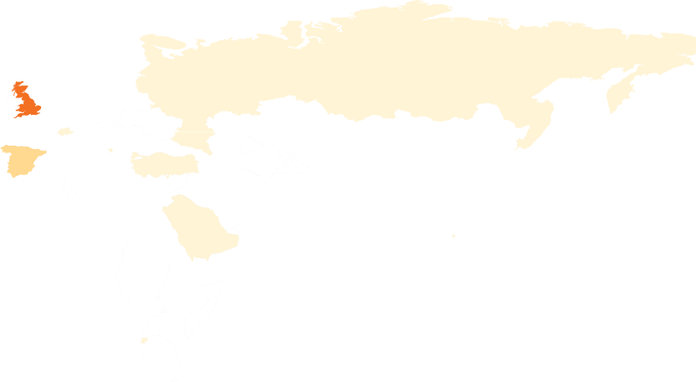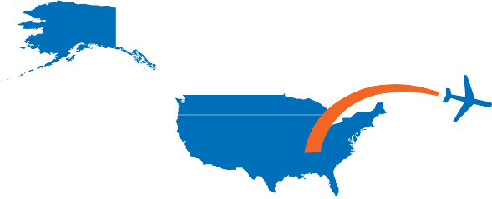
A Global Movement
Norway
Finland
Russia
Canada
United Kingdom
The Denmark
Ireland
Netherlands Poland
France
Germany Czech Republic
Switzerland Hungary
Croatia Bulgaria
United States
Spain
Italy Kosovo
Greece
Turkey
Cyprus
China
Morocco
Israel
United Arab Emirates
Japan
Mexico
Saudi Arabia
India
Number of International
Commitment Partners by Country
Virgin Islands
Taiwan
Hong Kong
Guatemala
Belize
Nicaragua
Senegal
Bangladesh
Thailand
Philippines
Costa Rica
Vietnam
Malaysia
Colombia
40-16
Ecuador
Kenya
Singapore
Rwanda
15-10
Brazil
9-5

4-1
Australia
Chile
New
Zealand
Argentina

In the United States, more than 400 U.S. colleges and universities have set targets and actions to significantly expand study abroad. Study abroad organizations, language, K-12 community, and international partners are supporting them by increasing funding and scholarships, expanding student diversity, designing new programs and engaging alumni.

MEETING AMERIC A ’S GL OBAL EDUCA TION CHALLENGE

Our network is addressing the key barriers to study abroad by:

Increasing Access & Awareness

By setting clear targets and actions, we are seeing results. 10 U.S. campuses are considering requiring study abroad and 12 have reported reaching their end of the decade study abroad target in 2014/15. Since March 2014, Generation Study Abroad has been featured in:
1,000+ News Stories 35,000+ Tweets
Over 40 Million reached on social media
59%

Increasing Funding
$55 Million in Student Scholarships
$2.7 Million in Faculty Grants

Reaching New Populations

Changing Perceptions
Minority or diverse ethnic backgrounds
74%
37%
Students with high financial need
71%
43%

First-generation students
27%

Students pursuing fields of study underrepresented in study abroad
52%
38%
Students with disabilities
25%
78% of study abroad offices at U.S. higher education institutions are engaging with their career office to help students articulate the value of study abroad.
10%

Internationalizing

Focusing on this student population

Saw an increase in study abroad among these students in 2014/15

the Curriculum 65% of international partners are collaborating with U.S partner institutions to
improve credit transfer.
70% U.S higher education institutions are integrating study abroad into curriculum.
Except where noted, figures listed here reflect responses submitted to the 2016 Generation Study Abroad
Annual Progress Survey, completed between January and July 2016 and reflects impact as of December 31, 2015. Figures do not represent actions or commitments pledged by all commitment partners to date.

Join Generation Study Abroad
IIE leads the Generation Study Abroad coalition in raising awareness of the need for students to gain language and cultural skills, identify and break down barriers, share innovative strategies, and to mobilize additional financial resources.

IIE actively seeks new partners and resources to give U.S. students the study abroad opportunities they need to succeed. For more information on how to join: www.generationstudyabroad.org

MEETING AMERIC A ’S GL OBAL EDUCA TION CHALLENGE
Teachers, administrators,
and study abroad alumni are on board.
Preparation for study abroad must begin long before college.
1,000+
Teachers &
administrators have pledged to engage their students
15,000+
Students & study
abroad alumni have joined the campaign as advocates
28%
of U.S. colleges & universities
have reached out to the K-12 community to help build the study abroad pipeline
@iieglobal #generationstudyabroad

