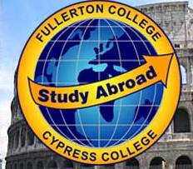

Student Acknowledgement of Liability
This form is for students who would like to apply for the Study Abroad program during a semester in which they do not currently meet the following two requirements at time of application, but will by the end of the semester:
- Passing of English 100
- 12-units of college credit

For students who are currently enrolled in English 100:
Provide the name of your instructor: ________________________________

Attach a letter from the instructor stating that you will most likely pass English 100 by the end of Spring, and what your current grade is.

For students who do not currently have 12 units of credit:
Provide the name of the instructor for each class, you’re currently taking:

Class: _______________ Instructor:________________
Class: _______________ Instructor:________________
Class: _______________ Instructor:________________
Class: _______________ Instructor:________________

Attach a letter from each instructor stating that you will most likely pass the class by the end of Fall, and what your current grade is.

I __________________ acknowledge that by applying for the Study Abroad program before I meet the minimum qualifications that I am taking a financial risk. If I am not successful in meeting the requirements by the end of the semester, I understand that I risk losing my deposit or that I can be responsible for the entire cost of the trip, unless I officially withdraw from the program by the dates on the AIFS application. I will not hold the North Orange County Community College District or AIFS responsible for money that I owe AIFS because I did not meet the individual qualifications.

Signature: ____________________________ Date: ___________________________

